A Close Call.
A: So, can you remember a time when you had a close call?
B: A close call…
A: Yeah, almost getting into trouble, or getting hurt, or even dying, almost dying?
B: Hmm..Ah, I had a really close call when I was just learning how to drive.
A: Oh yeah? What happened?
B: Well, I had to take a two-part driving test.
A: Two-part? Uh-huh.
B: Yeah, you know, first it was driving in local areas.
A: Right.
B: I wasn't too worried about that part.
A: Uh-huh.
B: But then came the part of driving on the highway.
A: Ohh, the highway. That's scary at first, huh?
B: Yeah, you know, because the cars drive so fast.
A: Right.
B: So, anyway, I drove the car and, you know, I got up on the
entrance ramp.
A: Yeah.
B: And the big test, you know, could I drive into the traffic
safely with the cars speeding by, you know?
A: I bet you were really nervous, huh?
B: Yeah, I was. Umm... but anyway, I got there and I was
supposed to, you know, put my foot on the brake -
A: Right, uh-huh.
B: - look to see if traffic was coming.
A: Right.
B: But I stepped on the gas.
A: Oh! You stepped on the gas!
B: Yeah.
A: Oh no!
B: Yeah, and in the rear-view mirror, I saw this eighteen-
wheeler coming...
A: Eighteen-wheeler! Wow! So what happened?
B: Well, my driving instructor turned the wheel and stepped
on the brake.
A: Oh that's good.
B: Yeah. So I didn't hit the truck.
A: You were lucky!
B: I was, I was.
Entrance-Ramp
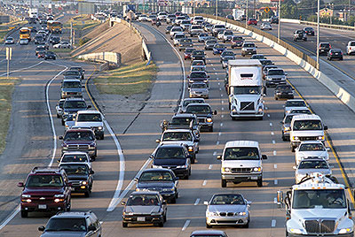
18-Wheeler
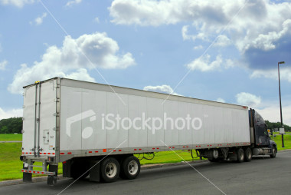

A: Oh that's good.
B: Yeah. So I didn't hit the truck.
A: You were lucky!
B: I was, I was.

